**Test case document**

**Endpoints**

|  |  |  |
| --- | --- | --- |
| **Function** | **Type** | **URL** |
| **/users** | | |
| sendEmail | POST | /sendmail/emailid |
| getAll | GET | / |
| getById | GET | /id |
| getByEmail | GET | /email/emailid |
| Add | POST | / |
| Delete | DELETE | / |
| update | POST | /updateUser |
| **/contents** | | |
| getAll | GET | / |
| getById | GET | /id |
| Add/Update | POST | / |
| delete | DELETE | /id |
| **/ratings** | | |
| getAll | GET | / |
| getById | GET | /id |
| Add/Update | POST | / |
| getAvgByContentId | GET | /content/id |

**Manual testing** for all API using Postman

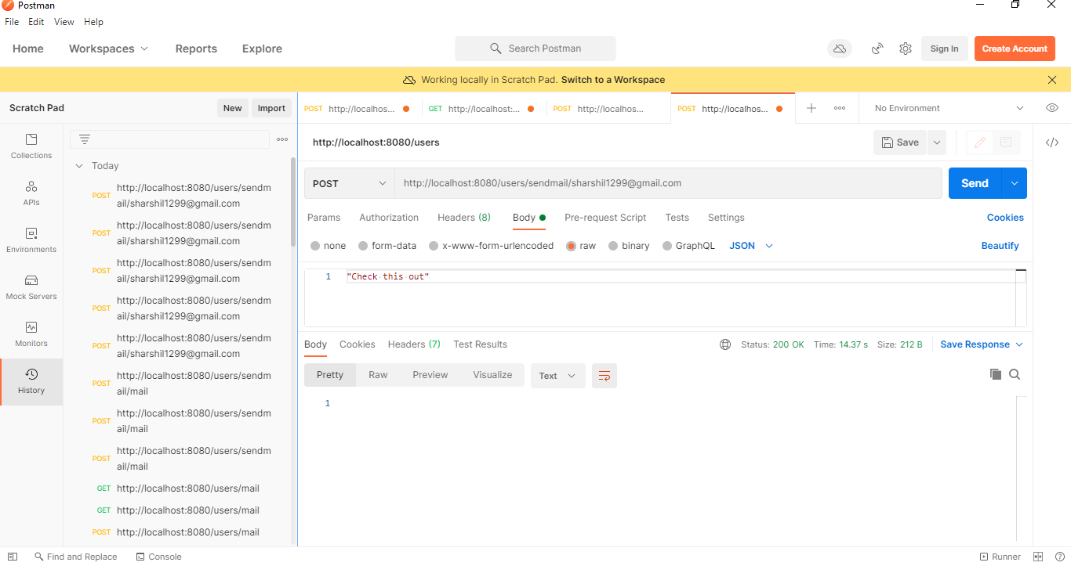

**Automated Testing**

